ECA0901 – DIGITAL SIGNAL PROCESSING

C01 – AT3 SIMULATION EXPERIMENT – 4
Design and Comparative Analysis of Butterworth, Chebyshev and Elliptic IIR Filters Using MATLAB
MATLAB CODE:
clc; clear; close all;
% Input specifications
Fs = 1000; Fp = 100; Fst = 150; Rp = 1;
Rs = 40; Wp = Fp/(Fs/2);
Ws = Fst/(Fs/2); BW = Fst - Fp;
% Minimum filter orders
[Nb,Wb] = buttord(Wp,Ws,Rp,Rs);
[Nc,Wc] = cheb1ord(Wp,Ws,Rp,Rs);
[Ne,We] = ellipord(Wp,Ws,Rp,Rs);
% Design filters
[bb,ab] = butter(Nb,Wb,'low');
[bc,ac] = cheby1(Nc,Rp,Wc,'low');
[be,ae] = ellip(Ne,Rp,Rs,We,'low');
% Display orders and coefficients
fprintf('Butterworth Order = %d\n',Nb);
disp('Butterworth Numerator:'); disp(bb);
disp('Butterworth Denominator:'); disp(ab);

fprintf('Chebyshev-I Order = %d\n',Nc);
disp('Chebyshev Numerator:'); disp(bc);
disp('Chebyshev Denominator:'); disp(ac);
fprintf('Elliptic Order = %d\n',Ne);
disp('Elliptic Numerator:'); disp(be);
disp('Elliptic Denominator:'); disp(ae);
% Frequency responses
[Hb,f] = freqz(bb,ab,2048,Fs);
[Hc,~] = freqz(bc,ac,2048,Fs);
[He,~] = freqz(be,ae,2048,Fs);
dB = 20*log10(abs(Hb)+eps);
dC = 20*log10(abs(Hc)+eps);
dE = 20*log10(abs(He)+eps);
%Magnitude response comparison
figure;
plot(f,dB,'b',f,dC,'r--',f,dE,'k-.');
grid on; ylim([-100 5]);
xlabel('Frequency (Hz)');
ylabel('Magnitude (dB)');
title('Magnitude Response Comparison');
legend('Butterworth','Chebyshev-I','Elliptic');
% Phase response comparison
figure;
plot(f,unwrap(angle(Hb)),'b', ...
f,unwrap(angle(Hc)),'r--', ...
f,unwrap(angle(He)),'k-.');
grid on;
xlabel('Frequency (Hz)');
ylabel('Phase (rad)');
title('Phase Response Comparison');
legend('Butterworth','Chebyshev-I','Elliptic');
% Measure passband ripple and stopband attenuation
pass = f <= Fp;
stop = f >= Fst;
rippleB = max(dB(pass))-min(dB(pass));
rippleC = max(dC(pass))-min(dC(pass));
rippleE = max(dE(pass))-min(dE(pass));
attB = -max(dB(stop)); attC = -max(dC(stop)); attE = -max(dE(stop));
% Percentage deviation from specifications
devB = abs(attB-Rs)/Rs*100;
devC = abs(attC-Rs)/Rs*100;
devE = abs(attE-Rs)/Rs*100;
% Comparative table
Filter = {'Butterworth';'Chebyshev-I';'Elliptic'};
Order = [Nb;Nc;Ne];
PassbandRipple_dB = [rippleB;rippleC;rippleE];
StopbandAttenuation_dB = [attB;attC;attE];
StopbandDeviation_percent = [devB;devC;devE];
Results = table(Filter,Order,PassbandRipple_dB,...
StopbandAttenuation_dB,StopbandDeviation_percent);
disp(Results);
fprintf('Transition Bandwidth = %.2f Hz\n',BW);

OUTPUT:
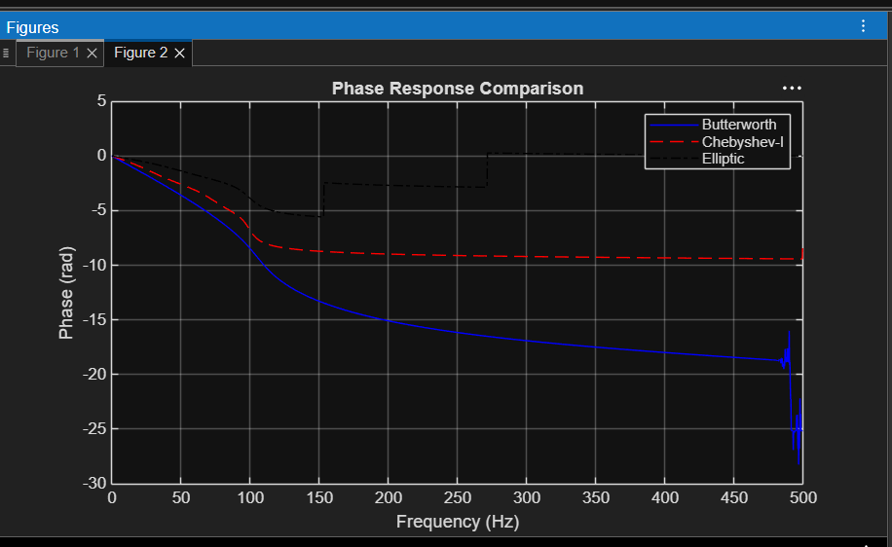

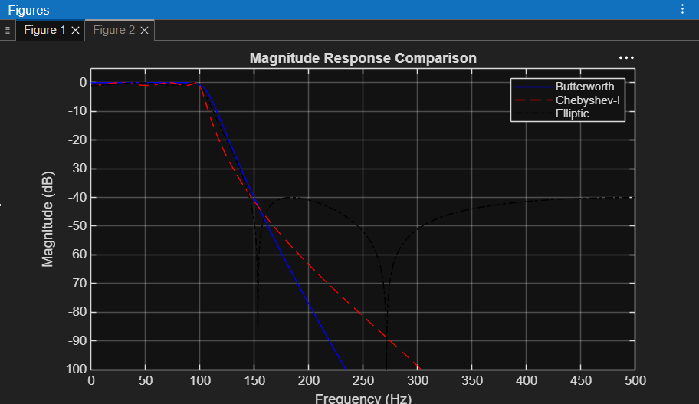

OUTPUT PARAMETERS:
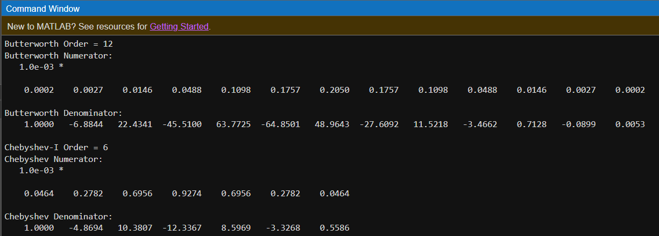
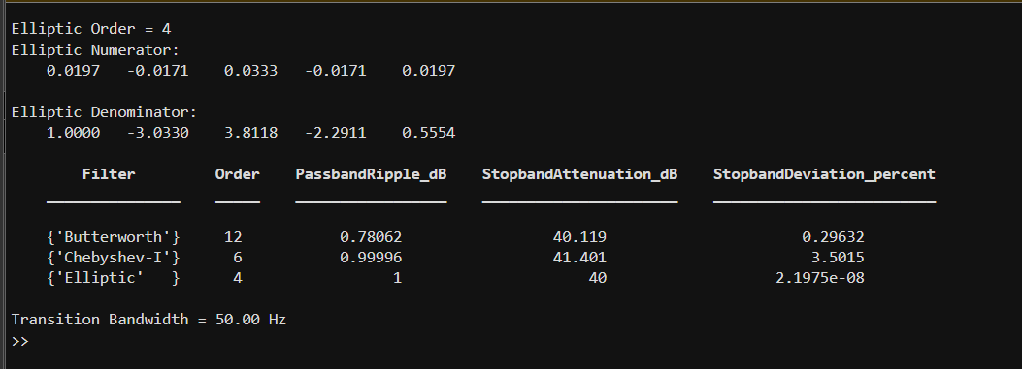

RESULT:
Design and Comparative Analysis of Butterworth, Chebyshev and Elliptic IIR Filters satisfied outcomes using MATLAB

